Goldhawk International

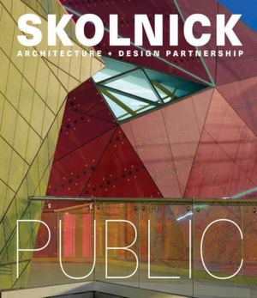
Skolnick Architecture + Design Partnership: Public/Private
Text by Lee Skolnick, Foreword by Paul Goldberger
September 2020 Architecture
ISBN: 978-1-938461-83-5
11” x 12” / 248 Pages
Price: £70
Territory: UK/Europe

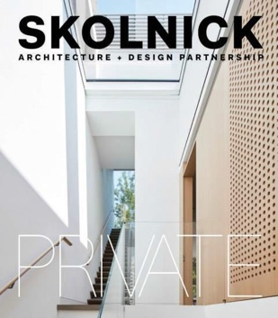
Skolnick Architecture + Design Partnership: Public/Private presents the first monograph from the award-winning New York-based architectural firm.

Covering nearly 40 years of work, the book—presented in a unique double-sided, two-cover format—exhibits projects in both the public and private sectors.

Included in the public section is a sprawling center for entrepreneurial education, a science center built in an old turbine hall, a light-filled synagogue, two colorful and bright public libraries, and a children’s museum inspired by Leonardo da Vinci.
The private side features a serenely spatial six-story townhouse, a sublimely linear beach house, a residence and matching studios for two painters, and luxurious twin villas in Anguilla.

With text by Founding Principal Lee Skolnick, and a foreword by Pulitzer Prize-winning architectural critic Paul Goldberger; each chapter provides valuable insight into the sensitive planning and highly intellectual process that goes into each project. Skolnick Architecture + Design Partnership: Public/Private celebrates the accomplishments of a firm that continues to operate at the top of their game.

SKOLNICK Architecture + Design Partnership is an award-winning, integrated design firm specializing in architecture, exhibit design, interpretation, master planning, and graphic design. Since 1980, their New York City-based studio has provided these services in the planning and design of museums, visitor centers, corporate offices, residences, and educational institutions.

For more information of this book and our other titles, please visit www.goldhawkinternational.com

